Short Technical Proposal

Student’s Name: Yong Hao

Student’s Name: Han Simeng

School: Nanyang Technological University

Tutor’s name: Koh Siew Tin

Date of Submission: 22/10/2017

**Intelligent Scuba Diving Nitrogen Level Sensor**

**Background:**

Driven by a keen interest for adventurous experiences and powerful global tourism trends, scuba diving is becoming an increasingly popular recreational sport. According to Professional Association of Diving Instructors (PADI), one million new divers are trained annually worldwide [1]. The safety issues related to scuba diving have been a big concern ever since the dawn of diving history. An average of 80 fatalities and 2,000 injuries are reported annually, in which 25% are due to decompression sickness and nitrogen narcosis [2]. Due to the high pressure of seawater, the nitrogen concentration in the blood vessel rises when a scuba diver is underwater. When the concentration reaches a certain level, nitrogen narcosis happens which causes impaired judgment of a diver [3]. Poor concentration ensues if the diver continues to stay at the same depth. Furthermore, the dissolved nitrogen will form bubbles on depressurization when a diver surfaces too fast. This induces numbness and vertigo [4]. Both nitrogen narcosis and decompression sickness are extremely dangerous illnesses for divers because they are not able to control themselves when affected by the related symptoms. In the worst scenario, divers may not be able to come up and might reluctantly lose their lives from drowning.

**Problem:**

The traditional diving regulator provides the divers with a table indicating the maximum length of time a diver can stay under water at a certain depth without experiencing nitrogen narcosis and decompression sickness during surfacing. However, such no-stop time is not accurate enough as it varies among people because of the differences in the conditions of their bodies. As a result, nitrogen narcosis and decompression sickness have badly affected hundreds of thousands of divers and a solution to it is desperately needed.

**Solution:**

The solution provided in this proposal is an intelligent nitrogen level sensor integrated with the breathing regulator.

The intelligent sensor contains two major components, one is the flow capacity and concentration sensor integrated with Bluetooth transmitter and the other is a preprogrammed chip. The device will be integrated inside the breathing regulator to record the absorbed nitrogen amount through each inhale and exhale.

Under initialization, the device will ask for the user’s body weight, then estimate the total volume of blood in the user’s body. When the user is underwater, the device will detect the flow speed of inhaling and exhaling along with the nitrogen concentration respectively. The computer calculates the exact amount of nitrogen of each whole breath and then derives the difference of the amount of nitrogen and adds it up to the accumulated nitrogen. The real-time information of blood nitrogen concentration will be sent to the dive computer integrated with the preprogrammed chip for calculating a user’s body tolerance of nitrogen.

The dive computer’s lighting indicator will range from green, yellow to red depending on the concentration of blood nitrogen.

Once the accumulated nitrogen has reached the level that will soon go beyond the tolerance of the diver but still enables the diver enough time for safe surfacing, the dive computer will alarm the diver by creating a loud sound and flashing beaming red lights. Then the diver will follow the instructions of the device to complete his safe ascent.

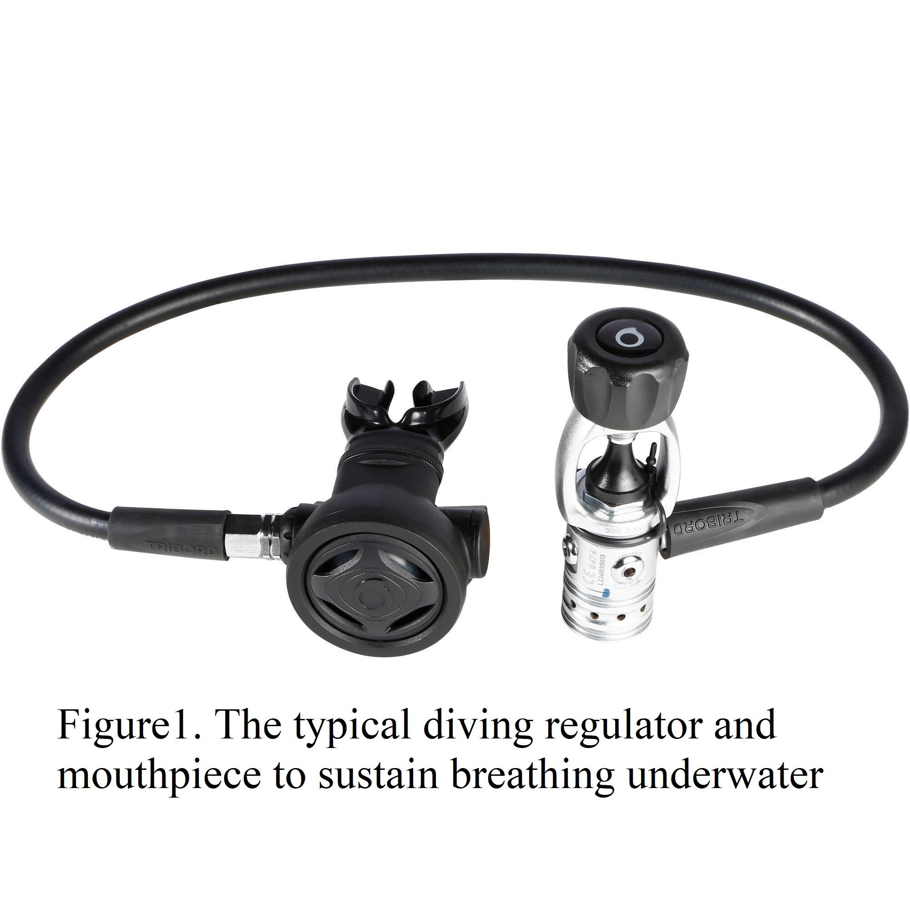[5]

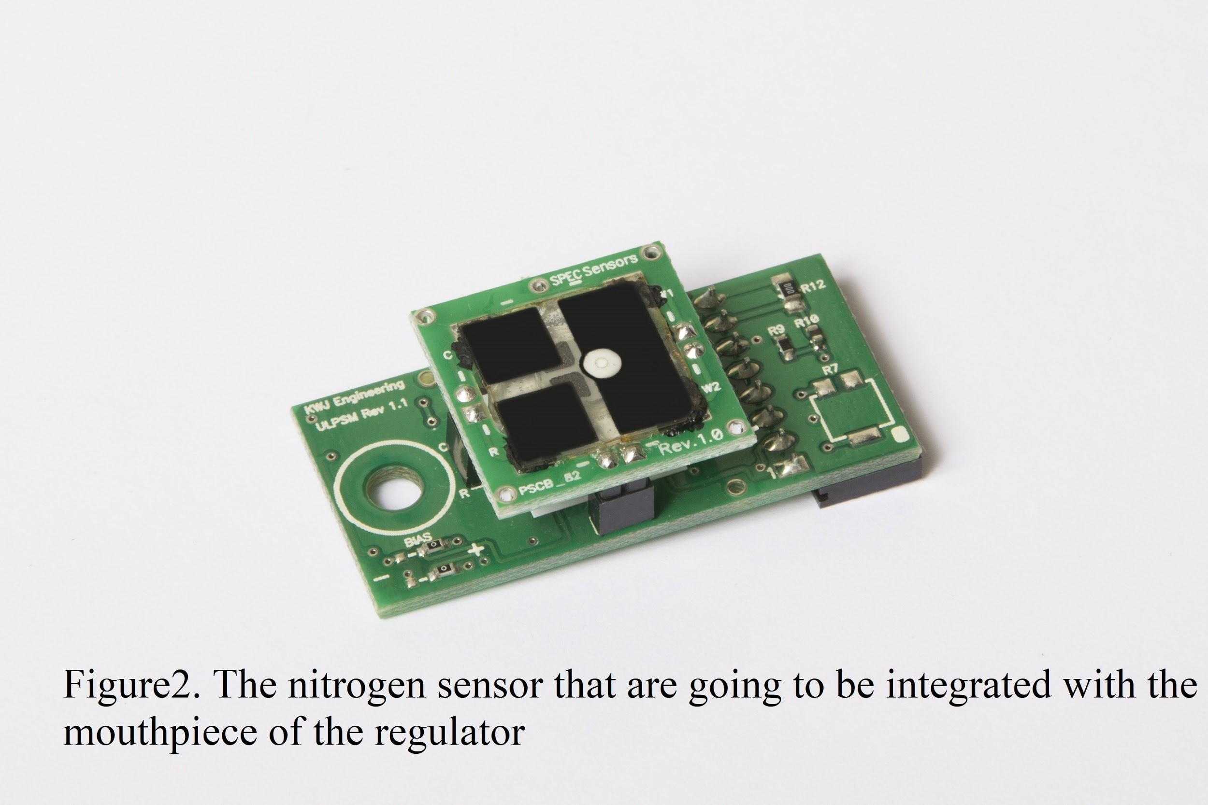[6]

**Benefits:**

The intelligent scuba diving nitrogen gas sensor will benefit divers and encourage people to experience scuba diving by enhancing the safety method and reducing fatalities. With more accurate and real-time data about body nitrogen levels, divers will be equipped with the capability of making more appropriate decisions when surfacing or facing an emergency. Divers will acquire more accurate no-stop time to have the nitrogen in their bodies released and mitigate the effects of decompression sickness and nitrogen narcosis. Thus, more people can enjoy themselves in recreational scuba diving with ensured safety. Beginners will be able to handle decompression sickness better, and experienced divers can plan and enjoy deep diving without worrying about nitrogen narcosis.

**Implementation:**

To produce and develop this device, three steps will be taken.

1. Cooperating with a computer-engineering research team to produce a

prototype.

1. Collaborating with a company for mass production.
2. Promoting the selling and make more improvements with the feedback of

customers.

**Costs:**

Nitrogen flow capacity and concentration sensor $200

Pre-programmed chip $10

Bluetooth transmitter $5

Bluetooth receiver $5

Total $220

**Conclusion:**

The current solution to avoiding decompression sickness and nitrogen narcosis is not appropriate as it fails to take into consideration the physical condition of each scuba-diving individual. The proposed intelligent nitrogen sensor aims to give the divers more accurate and timely alerts on when to surface. This will significantly reduce the number of people suffering from decompression sickness and nitrogen narcosis and make scuba diving a safer sport as a whole. The intelligent diving nitrogen sensor is useful and beneficial to the divers and therefore its development should be supported.

Words:797

**References**

[1] L. Mowery. (2017, June, 2). *Will the sport of scuba diving end by 2015?* [Online]

Available: <https://www.forbes.com/sites/lmowery/2017/06/02/will-the-sport-of-scuba-diving-end-by-2050/#2cd10a1434db>

[2] Undercurrent.org. (2017). *How Many Divers Are There?* [Online]

Available:

https://www.undercurrent.org/UCnow/dive_magazine/2007/HowManyDivers200705.html

[3] M. Hobbs. (2008, Jan, 30). *Subjective and behavioral responses to*

*nitrogen narcosis and alcohol.* [Online]

Available: <http://archive.rubicon-foundation.org/xmlui/bitstream/handle/123456789/8101/18619113.pdf?sequence=1>

[4] Drugs.com (2017). *Decompression Sickness Guide: Causes, Symptoms and*

*Treatment.* [Online]

Available: <https://www.drugs.com/health-guide/decompression-sickness.html>

[5] tribord.co.uk (n.d.). *How To Choose Your Scuba Diving Regulator.* [Online]

Available:

<https://www.tribord.co.uk/advice/how-choose-your-scuba-diving-regulator-a_22970>

[6] Spec-Sensors.com (n.d.). *Ultra-Low Power Analog Sensor Module for NO2*. [Online]

Available:

<https://www.spec-sensors.com/product/ultra-low-power-analog-sensor-module-no2/>